1 Can you find and open the WiFi Config application in the main menu *(Hint: It is under the Preferences sub-menu)*.

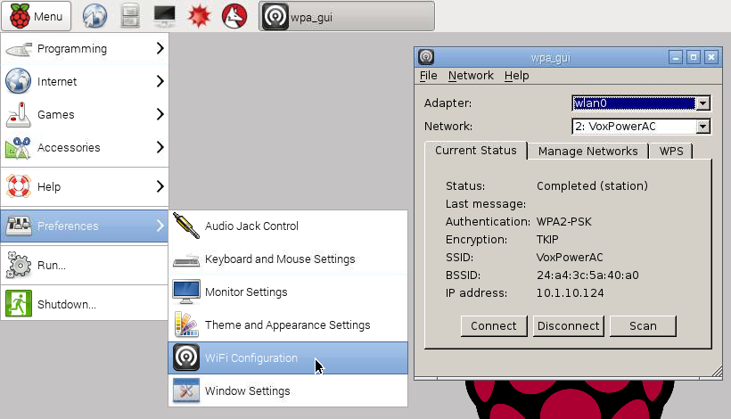

2 Click on the scan button and a second window will open. This new window lists all of the wireless network access points that the Pi can currently detect. Find yours and double click on it.

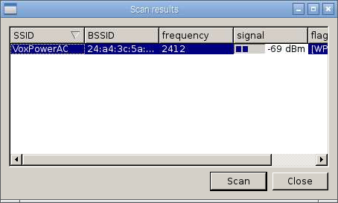

3 This opens a third window. Enter your password for your wifi network in the PSK field and then click the Add button.

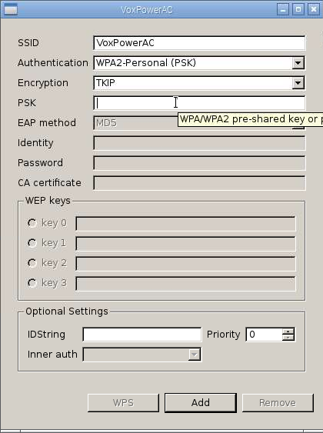

4 Back on the first window your connection should now be set up for use. You can use the Connect and Disconnect buttons there to connect or disconnect from the wireless network. Notice that the IP address of the Pi is shown at the bottom of this window.

